

**BSc (Hons) in Information Technology**

**Software Engineering – Year 3**

**SE3050 – User Experience engineering**

**Semester 2, 2021**

**Lab sheet 06**

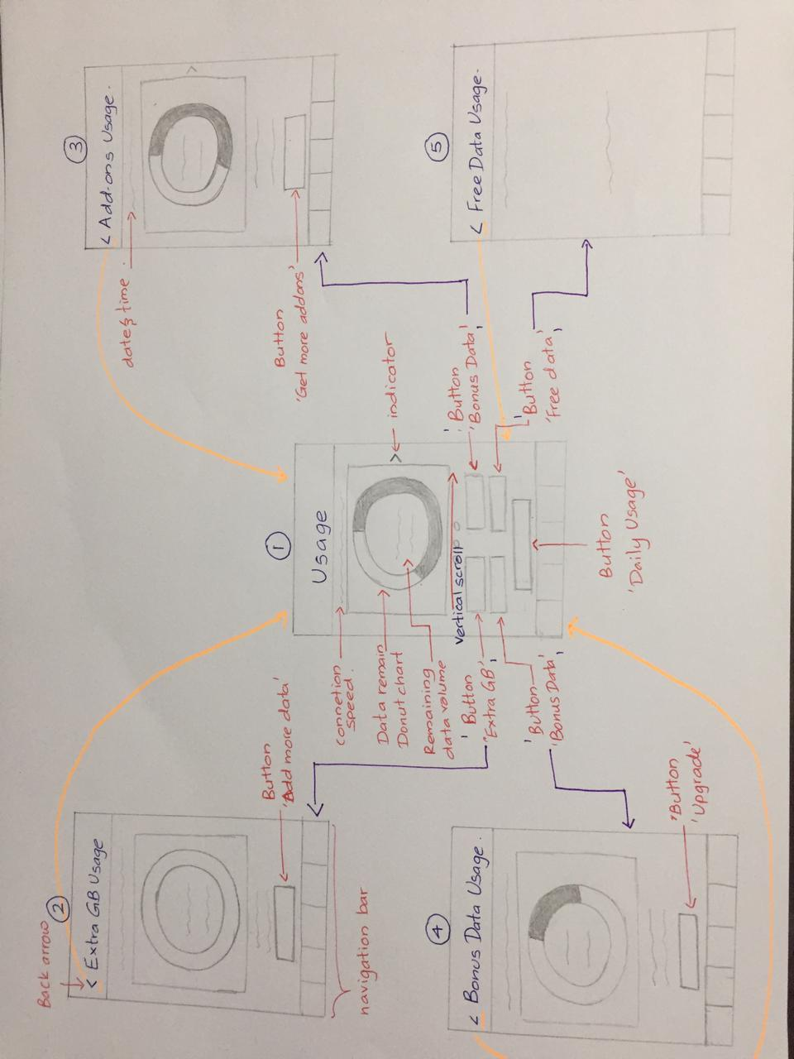**Member 01 – Goonawardena M.V.S ( IT19135830)**

Sketch

|  |  |
| --- | --- |
| **Screen Shots of the GUI (Version 2.0)** | **Usability issues of the Version 1.0** |
| **Prototype**  **Wireframe** | The redesigned prototype is solving the major issues in the existing application.   * In the V 1.0,the color of the navigation bar was different, therefore changed it appropriately. * The background color in V 1.0 was fully white, so with the color change of the navigation bar in V 2.0, changed the background color accordingly. * In V 1.0, the consumed data volume in the donut chart ( depicted in grey) was in black. Changed the color to grey accordingly. * One major issue in V 1.0 was that the card views and the buttons were square shaped. So in the finalized version , the card views and buttons were made with rounded corners. * Indicator arrow added to indicate swipe motion in V 2.0 * The ‘Daily usage’ button color changed. |
| **Prototype**  **Wireframe** | The redesigned prototype is solving the major issues in the existing application.   * In the V 1.0,the color of the navigation bar was different, therefore changed it appropriately. * The background color was changed * In V 1.0, the consumed data volume in the donut chart ( depicted in grey) was in black. Changed the color to grey accordingly. * The card views and buttons were made with rounded corners. * In V 1.0, the validity period was given in the card view as well as outside. The validity period was removed from the card view in V 2.0 |
| **Prototype**  **Wireframe** | The redesigned prototype is solving the major issues in the existing application.   * In the V 1.0,the color of the navigation bar was different, therefore changed it appropriately. * The background color was changed * In V 1.0, the consumed data volume in the donut chart ( depicted in grey) was in black. Changed the color to grey accordingly. * The card views and buttons were made with rounded corners. * In V 1.0, the validity period was given in the card view as well as outside. The validity period was removed from the card view in V 2.0 * Indicator arrow added to indicate swipe motion in V 2.0 |
| **Prototype**  **Wireframe** | The redesigned prototype is solving the major issues in the existing application.   * In the V 1.0,the color of the navigation bar was different, therefore changed it appropriately. * The background color was changed * In V 1.0, the consumed data volume in the donut chart ( depicted in grey) was in black. Changed the color to grey accordingly. * The card views and buttons were made with rounded corners. * In V 1.0, the validity period was given in the card view as well as outside. The validity period was removed from the card view in V 2.0 |
| **Prototype**    **Wireframes** | The redesigned prototype is solving the major issues in the existing application.   * In the V 1.0,the color of the navigation bar was different, therefore changed it appropriately. * The background color was changed |

**Member 02 – A.L.A.D.C.V. Ambegoda ( IT19134536)**

**Sketch**

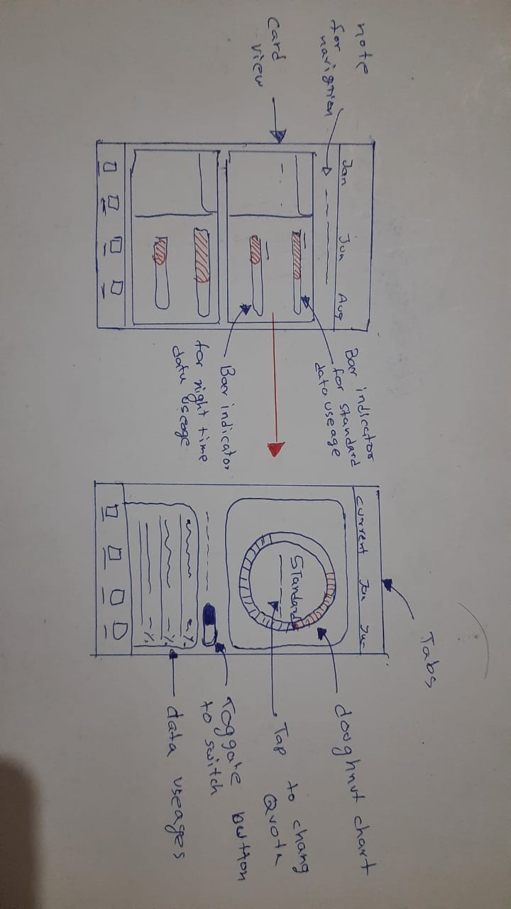

|  |  |
| --- | --- |
| **Screen Shots of the GUI (Version 2.0)** | **Usability issues of the Version 1.0** |
| Prototype      Wireframes    **Prototype**    **Wireframes** | The redesigned prototype is solving the major issues in the existing applications Daily Usage.   * In version 2 added a note to mention that users can be navigate in to detailed report by tapping on a card. * As per users feedback the colors of the indication bars were kept as same to the current SLT application. Than the colors in version 1 * The bottom navigation was in blue color in version 1.0 so the icons in the navigation was not that clear, so it was suggested to change to white color. * As well as the background color in version 1.0 was bit dark than now so it gives the entire interface a dull look so in the version 2.0 background color was lighten.   The redesigned prototype is solving the major issues in the existing applications Detail Report.   * In Version 1 In doughnut chart when there are no values the color is red color. Since it makes people confuse, the color is change to gray. * The toggle button and the note were placed on the top in version one. Since it controls the behavior of the bottom panel. In version 2, it is placed above the bottom panel * As well as the background color in version 1.0 was bit dark than now so it gives the entire interface a dull look so in the version 2.0 background color was lighten. * The bottom navigation was in blue color in version 1.0 so the icons in the navigation was not that clear, so it was suggested to change to white color. |

**Member 03 – A.R Kulatunga ( IT19136134)**

**Sketch**

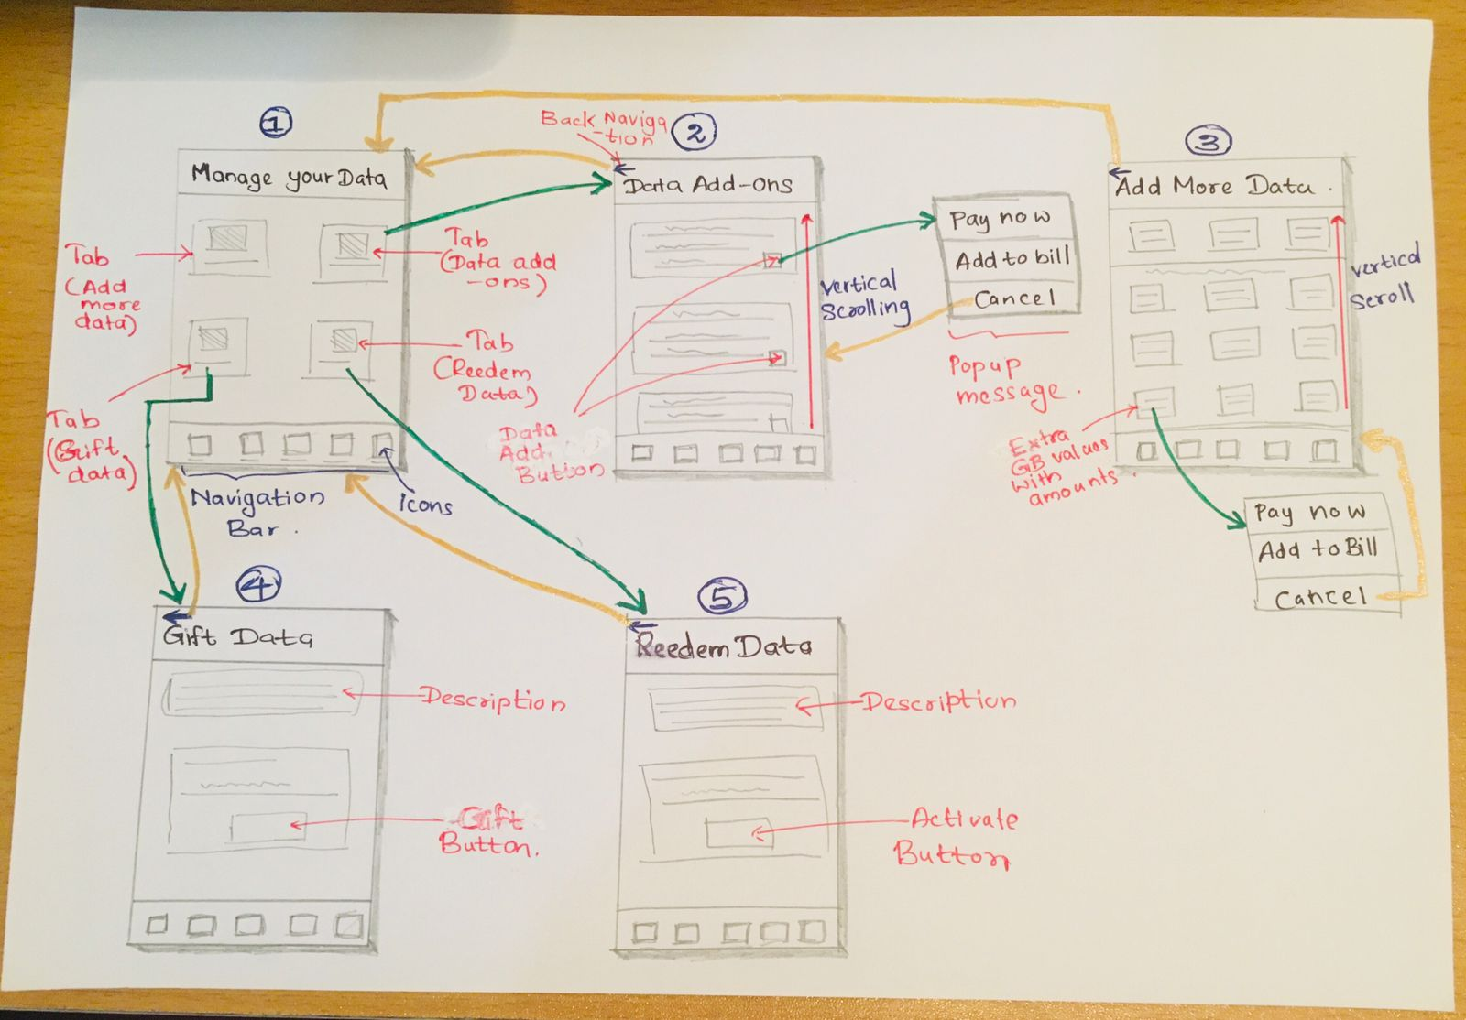

|  |  |
| --- | --- |
| **Screen Shots of the GUI (Version 2.0)** | **Usability issues of the Version 1.0** |
| **Prototype**    **Wireframe**  **F:\SLIIT 3rd Year Sem2\User Experience Engineering (UEE)\Lab 06\Snips\WireFrames\Google Pixel 2 - 4.png** | The redesigned prototype is solving the major issues in the existing application.   * Also in the version 1.0, the tabs were arrange as rectangle shape card view so in the user testing it was suggested to changes to square shape card views so the interface does not look blank in the bottom of the page. * In addition, it is more visible to user and easy to tap to navigate than in version 1.0. * Also, the bottom navigation was in blue color so the icons in the navigation was not that clear so it was suggest to change to white color. * As well as the background color in version 1.0 was bit dark than now so it gives the entire interface a dull look so in the version 2.0 background color was lighten. |
| **Prototype**      **Wireframe**  **F:\SLIIT 3rd Year Sem2\User Experience Engineering (UEE)\Lab 06\Snips\WireFrames\Google Pixel 2 - 5.png**  **F:\SLIIT 3rd Year Sem2\User Experience Engineering (UEE)\Lab 06\Snips\WireFrames\Google Pixel 2 - 17.png** | The redesigned prototype is solving the major issues in the existing applications Data Add-on page.   * In the version 1.0 the major issues was topics in the card view was in black color so it was suggest to change to the white color. * Also in the version 1.0 the card views was not curve. * In addition the bottom navigation was in blue color so the icons in the navigation was not that clear so it was suggest to change to white color. * As well as the background color in version 1.0 was bit dark than now so it gives the entire interface a dull look so in the version 2.0 background color was lighten. * Also in version 1.0 one a user click on the Data Add button the payment methods were shown in a separate interface so in the user testing the user asked to change the payment methods to show as a pop up other than using a separate interface. |
| **Prototype**        **Wireframe**  **F:\SLIIT 3rd Year Sem2\User Experience Engineering (UEE)\Lab 06\Snips\WireFrames\Google Pixel 2 - 8 (1).png**  **F:\SLIIT 3rd Year Sem2\User Experience Engineering (UEE)\Lab 06\Snips\WireFrames\Google Pixel 2 - 18 (1).png**  **F:\SLIIT 3rd Year Sem2\User Experience Engineering (UEE)\Lab 06\Snips\WireFrames\Google Pixel 2 - 17.png** | The redesigned prototype is solving the major issues in the existing applications Add more Data.   * Major issue in version 1.0 was the data packages was not clearly separated son in the version 2.0 those ranges was highlighted with a background color. * In addition the bottom navigation was in blue color so the icons in the navigation was not that clear so it was suggest to change to white color. * As well as the background color in version 1.0 was bit dark than now so it gives the entire interface a dull look so in the version 2.0 background color was lighten. * Also in version 1.0 once a user click on the Activate button the payment methods were shown in a separate interface so in the user testing the user asked to change the payment methods to show as a pop up other than using a separate interface. |
| **Prototype**    **Wireframe**  **F:\SLIIT 3rd Year Sem2\User Experience Engineering (UEE)\Lab 06\Snips\WireFrames\Google Pixel 2 - 10.png** | The redesigned prototype is solving the major issues in the existing applications Gift Data.   * The bottom navigation was in blue color in version 1.0 so the icons in the navigation was not that clear so it was suggest to change to white color. * As well as the background color in version 1.0 was bit dark than now so it gives the entire interface a dull look so in the version 2.0 background color was lighten. |
| **Prototype**    **Wireframe**  **F:\SLIIT 3rd Year Sem2\User Experience Engineering (UEE)\Lab 06\Snips\WireFrames\Google Pixel 2 - 6.png** | The redesigned prototype is solving the major issues in the existing applications Redeem Data.   * The bottom navigation was in blue color in version 1.0 so the icons in the navigation was not that clear so it was suggest to change to white color. * As well as the background color in version 1.0 was bit dark than now so it gives the entire interface a dull look so in the version 2.0 background color was lighten. |

**Member 04 – S.V. Wanigasekara ( IT19167992)**

**Sketch**

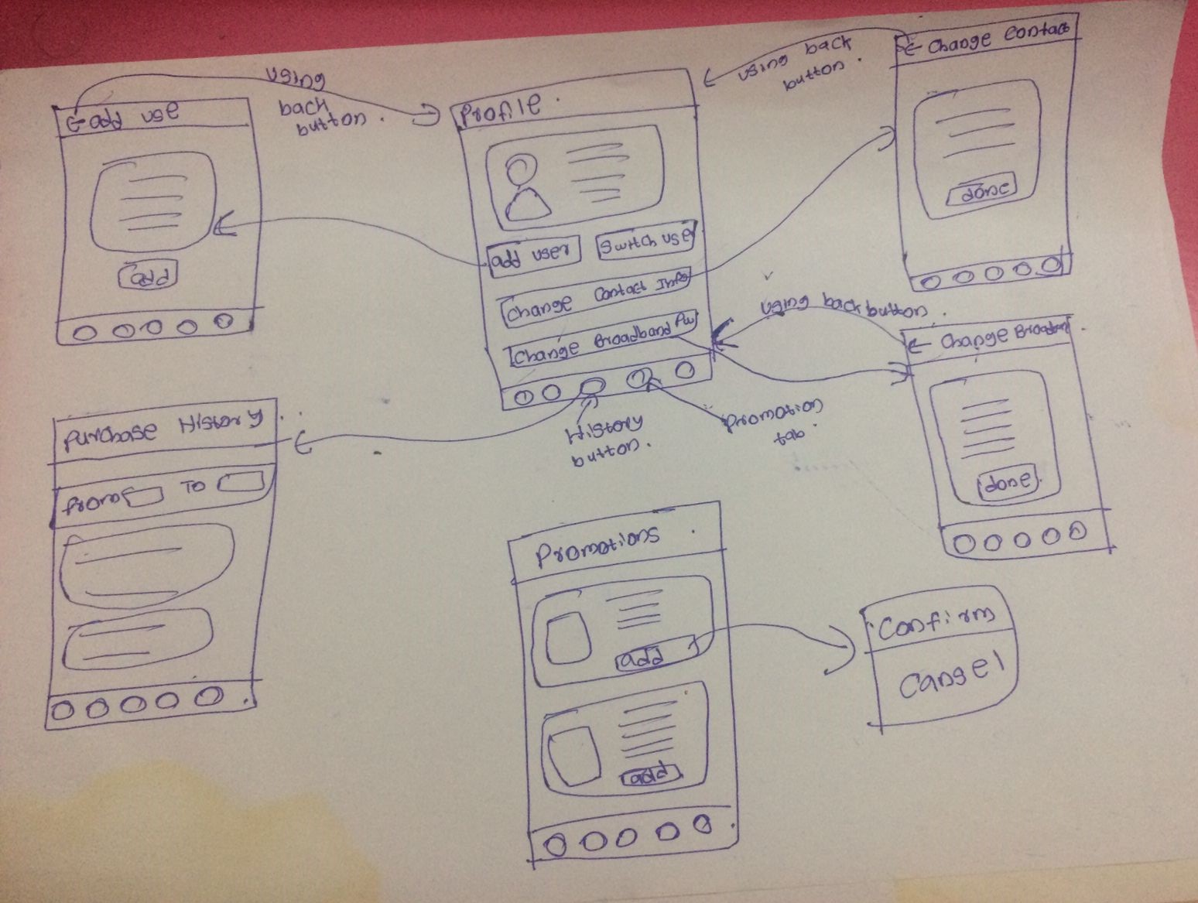

|  |  |
| --- | --- |
| **Screen Shots of the GUI (Version 2.0)** | **Usability issues of the Version 1.0** |
| **Prototype**    **Wireframe** | The redesigned prototype is solving the major issues in the existing applications Promotion.   * The bottom navigation was in blue color in version 1.0 so the icons in the navigation was not that clear so it was suggest to change to white color. * As well as the background color in version 1.0 was bit dark than now so it gives the entire interface a dull look so in the version 2.0 background color was lighten. * In version 1.0 Add Promotion Button also not curve. * Major issue in version 1 .0 rectangle shape card views so in the user testing it was suggested to changes to square shape card views to some curved one. |
| **Prototype**    **WireFrame**    **Prototype**    **Wireframes**    **Prototype**    **Wireframes**    **Prototype**    **Wireframe**   | The redesigned prototype is solving the major issues in the existing applications Profile.   * The bottom navigation was in blue color in version 1.0 so the icons in the navigation was not that clear, so it was suggest to change to white color. * As well as the background color in version 1.0 was bit dark than now so it gives the entire interface a dull look so in the version 2.0 background color was lighten. * In version 1.0 sign out button color is grey color and. so that button not highlighted, and it has some dull look. So, it was suggest to change blue color.   The redesigned prototype is solving the major issues in the existing applications Purchase History.   * The bottom navigation was in blue color in version 1.0 so the icons in the navigation was not that clear, so it was suggest to change to white color. * As well as the background color in version 1.0 was bit dark than now so it gives the entire interface a dull look so in the version 2.0 background color was lighten. * In version 1.0 card view not curved.   The redesigned prototype is solving the major issues in the existing applications change contact info.   * The bottom navigation was in blue color in version 1.0 so the icons in the navigation was not that clear, so it was suggest to change to white color. * As well as the background color in version 1.0 was bit dark than now so it gives the entire interface a dull look so in the version 2.0 background color was lighten.   The redesigned prototype is solving the major issues in the existing applications change Broadband password.   * The bottom navigation was in blue color in version 1.0 so the icons in the navigation was not that clear, so it was suggested to change to white color. * As well as the background color in version 1.0 was bit dark than now so it gives the entire interface a dull look so in the version 2.0 background color was lighten. |
| **Prototype**    **Wireframe** | The redesigned prototype is solving the major issues in the existing applications Add User.   * The bottom navigation was in blue color in version 1.0 so the icons in the navigation was not that clear, so it was suggested to change to white color. * As well as the background color in version 1.0 was bit dark than now so it gives the entire interface a dull look so in the version 2.0 background color was lighten. * In version 1.0 sign out button color is grey color and. so that button not highlighted, and it has some dull look. So, it was suggest to change blue color. |

**User Testing Scripts**

Hi, Lasal thank you again for taking your time and participating in this study.

So before we begin I will give you a brief introduction how the test happens and how it will work. In this session I will give you 2 task to complete and also will ask some questions as we go along. So with the task I will give you a bit of context behind it and what you hope to achieve.

Ok, let us get started with the process.

[Task 01]

Assume you are having the finals in the next week so you want to go through your lecture videos. So for the SLT have given a specific package for eduscope. So can you go ahead and show me how activate that package.

What do you think about the interfaces?

[Task 02]

Assume your data package is over before the month ends. So you want to purchase extra GB to do you work. Therefore, can you show me how you would activate extra GB?

What do you think about the interfaces?

[Task 03]

As you know, SLT provides promotion for different months and for various occasions. So assume you need to check the promotion so what will be the process to view promotions.

What do you think about the interfaces?

Hi, Ayesha thank you again for taking your time and participating in this study.

So before we begin I will give you a brief introduction how the test happens and how it will work. In this session I will give you 2 task to complete and also will ask some questions as we go along. So with the task I will give you a bit of context behind it and what you hope to achieve.

Ok, let us get started with the process.

[Task 01]

Assume you want to check the remaining data volume. So how will you view the data balance? Can you say me the amount in GB?

What do you think about the interfaces?

[Task 02]

Assume you want to check the daily usage of data for YouTube. So can you go ahead and check the usage

What do you think about the interfaces?

[Task 03]

Can you sign out from your account?

What do you think about the interfaces?

**Interview -1 Video Link**

[**https://drive.google.com/file/d/1QxFuwGUG20cTfiUvf65ayI4nW6WjMOa9/view?usp=sharing**](https://drive.google.com/file/d/1QxFuwGUG20cTfiUvf65ayI4nW6WjMOa9/view?usp=sharing)

**Interview -2 Video Link**

[**https://drive.google.com/file/d/1xpJ8BhsaC-Tv-N73By2UAwgPXe1KIfy7/view?usp=sharing**](https://drive.google.com/file/d/1xpJ8BhsaC-Tv-N73By2UAwgPXe1KIfy7/view?usp=sharing)

**Version 1.0 Prototype**

**Link to prototype -** [**https://www.figma.com/file/4JDmslFL770MbdnZaq3om8/SLT-Mobile-App-Version-1.0?node-id=0%3A1**](https://www.figma.com/file/4JDmslFL770MbdnZaq3om8/SLT-Mobile-App-Version-1.0?node-id=0%3A1)

**Version 2.0 Prototype**

**Link to prototype -** [**https://www.figma.com/file/1YIkfYzKauW0m5FempUQPD/SLT-Mobile-App-Version-2.0?node-id=312%3A282**](https://www.figma.com/file/1YIkfYzKauW0m5FempUQPD/SLT-Mobile-App-Version-2.0?node-id=312%3A282)

**Contribution**

|  |  |  |  |
| --- | --- | --- | --- |
| **Group Number** | **2021S2_REG_WE_40** | | |
| **Registration No** | | **Name** | **Contribution** |
| **IT19135830** | | **Goonawardena M.V.S** | * **Sketch** * **Wireframes** * **Prototype Version 1.0** * **Prototype version 2.0** * **User testing scripts** |
| **IT19134536** | | **A.L.A.D.C.V. Ambegoda** | * **Sketch** * **Wireframes** * **Prototype Version 1.0** * **Prototype version 2.0** * **User testing scripts** |
| **IT19136134** | | **A.R. Kulatunga** | * **Sketch** * **Wireframes** * **Prototype Version 1.0** * **Prototype version 2.0** * **User testing scripts** |
| **IT19167992** | | **S.V. Wanigasekara** | * **Sketch** * **Wireframes** * **Prototype Version 1.0** * **Prototype version 2.0** * **User testing scripts** |